HashMap or HashTable allows us to store key-value pair. Keys must be unique. In order to check the uniqueness, hashCode() and equals() methods of key are called. Let’s assume using the string length to generate the hashcode. Here , we can have the problem of collisions (several keys with the same length).

Buckets
Now, we can solve the problem of collisions by having an array of (references to) linked lists rather than simply an array of keys/values. Each little list is generally called a bucket.
We end up with a structure something like this:
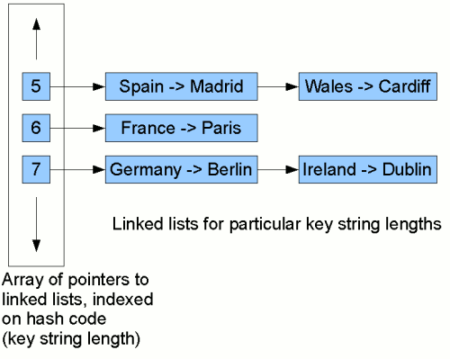
Each node in the linked lists stores a pairing of a key with a value. Now, to look for the mapping for, say, Ireland, we first compute this key's hash code (in this case, the string length, 7). Then we start traversing the linked list at position 7 in the table. We traverse each node in the list, comparing the key stored in that node with Ireland. When we find a match, we return the value from the pair stored in that node (Dublin). In our example here, we find it on the second comparison. So although we have to do some comparisons, if the list at a given position in the table is fairly short, we'll still reduce significantly the amount of work we need to do to find a given key/value mapping.

